El Dorado County Oral Health Community Needs Assessment

El Dorado Oral Health Program

Conducted and written by:
Catalina Reinhart

El Dorado Health and Human Services Agency
Public Health Division
[address]

Acknowledgements:
This publication was made possible by Proposition [#]
A special thanks to the Oral Health Advisory Committee of El Dorado County and all of the interviewed and surveyed participants.
Thank you to Kristin Becker and Constance Mote for their support and guidance.
Executive Summary
Key Findings
Approximately 191,185 individuals reside in El Dorado County, and while socioeconomic status of residents is greater than the median in California, significant disparities linked to household income, educational level, native language, and country of origin exist in oral health care and accessibility. In El Dorado County, those who were certified eligible were 22.6% of the population, in 2023.
The population of Alpine County is estimated at around 1,190 individuals.
Many residents remain unaware that tooth decay has long-lasting negative effects, including negative impacts related to physical, psychological, social, and economic well-being, and is the most common preventable childhood disease in the US. Research suggests that parents with untreated caries do not know that this infectious disease can be passed on to their newborns through their saliva. Many pregnant women believe that dental care during pregnancy is unsafe, and they are unaware that a dental visit during pregnancy is recommended (1). Despite this evidence, only 55% of pregnant women in El Dorado County visit a dentist during their pregnancy. For women with low socioeconomic status, pregnancy provides a unique insight into obtaining Medicaid insurance, and having the ability to visit dental providers. However, most pregnant women still do not seek dental care due to myth and misunderstanding of the relationship on pregnancy and oral health.
- In 2020, 51.3% of children aged 1-4 in the United States, had a dental exam or cleaning in the past 12 months. In contrast, 96.7% have seen a physician (2).
- 67% of Transitional Kindergartners/Kindergartners in El Dorado County are reported to have received the mandatory school entrance oral health assessment, in 2024.
- Key Informants identified the lack of dentists accepting Medi-Cal as serious barrier, as well as the total lack of specialty dentists in El Dorado County.
- In 2022, approximately 56% of adults in the U.S. did not seek care from an oral health provider or did not seek emergency care. Nearly a quarter of adults (24%) could not afford to seek care for their oral health problems (3).
“Oral health and dental care are as important as the medical and mental health care.” – key informant
Recommendations

Introduction
Poor dental health can threaten the health and normal development of young children and compromise the general health and wellbeing of adults. Research continuously indicates that poor dental health is directly linked to several chronic medical conditions including cancer, diabetes and heart disease/stroke. Oral health care is particularly important for the health of infants, young children, new mothers, and women who are pregnant or may become pregnant. Untreated dental problems during pregnancy can contribute to poor birth outcomes and neonatal mortality. It can have devastating effects on the social functioning, self-esteem, productivity, and overall quality of life of young and old alike.
The purpose of this oral health needs assessment is to provide a glimpse of the state of oral health in El Dorado and Alpine Counties, and to identify oral health needs, risk factors, resources, gaps and priorities, especially in underserved areas and with vulnerable population groups. Oral health surveillance systems in El Dorado and Alpine Counties are sparse. Many statewide systems such as the California Health Interview Survey (CHIS) and the Behavioral Risk Factor Surveillance System (BRFSS) either do not include El Dorado County residents, or the data are not statistically significant due to the sample size. This report identifies benchmarks, where available and priorities for the establishment of new surveillance systems.
Funding for this program is part of a 5-year oral health grant to El Dorado County from Proposition 56, the California Healthcare, Research and Prevention Tobacco Tax Act of 2016, which provides $30 million annually to activities that support the state 2022-2027 State Oral Health Plan. El Dorado County received funding to expand the capacity to coordinate public health activities that support oral health education, disease prevention, surveillance, linkages to treatment and case management.
We acknowledge the significant contribution by the members of the Oral Health Advisory Committee and the Alpine Health and Wellness Coalition for their commitment and dedication. The findings from this oral health needs assessment will be used to implement strategies that prioritize underserved areas and populations to continue in making progress toward achieving state and local oral health goals and objectives.
Background
The Burden of Oral Disease
The status of oral health is directly linked to the overall health of a person, from cardiovascular health to adverse pregnancy outcomes (4). Oral health prevention begins during pregnancy and continues from childhood through adulthood. The most common causes of disease due to oral health include tooth loss, dental caries, periodontal disease, and oral cancer (5) . Oral health is more than just healthy teeth, but it means to be free of tooth decay and gum disease, and other oral health conditions that affect the mouth and throat (6). There are a variety of challenges to achieving optimal oral health that affect the most vulnerable populations for social, economic, and geographic reasons (6). Oral health conditions are preventable, and it is important to understand the issues El Dorado County faces before there can be improvements to the overall health of the population.
Dental Caries
Dental caries, also known as tooth decay, is the most common type of chronic disease in children and adults that involves the breakdown of tooth enamel (7). Tooth decay is caused by bacteria in the mouth using sugar from foods and drinks that dissolve and damage the teeth. If left untreated, teeth can be destroyed and the nerves of the teeth can be affected, leading to pain, infection and rarely death (WHO). Tooth decay is a preventable disease, yet it remains the most common chronic disease of children and adolescents aged 6 to 19 years of age (8). Additionally, adults experience tooth decay on the root surfaces of teeth and are susceptible to gum resection as a result (4,8). Although dental caries are largely preventable, they are still extremely common in the United States.
Periodontal Disease
Periodontal disease is a very widespread, yet largely preventable, condition which negatively affects people’s overall well-being and quality of life. It is defined as an inflammatory disease that affects tooth-supporting gums and bones (8,9). Like dental caries, periodontal disease is caused by bacteria. Bacteria present in the mouth reside in plaque that develops on teeth. If plaque is not removed by tooth brushing and flossing, it will harden into calculus (tartar), which can cause inflammation. Chronic inflammation of the gums (gingivitis) is an early sign of periodontal disease (8). In some cases, gingivitis may progress to periodontitis, a serious condition that destroys tooth-supporting tissues and bone, and then to severe periodontitis, which leads to rapid tooth loss (9,10). From 2009 to 2014, roughly 42% of U.S. adults 30 years of age and older experience some form of periodontal disease (9).
Tooth Loss
The most common reasons for tooth loss in adults are tooth decay and periodontal disease. From 2018 to 2022, tooth loss among adults aged 65 and older, have been decreasing from 13.5% (2018) of tooth loss to 11.8% (2022) (11). Tooth loss, combined with poor muscle tone and ability to chew can significantly impact the life of older adults. The loss of teeth can be psychologically traumatic and hinder social functioning (12).
Oral and pharyngeal cancers
“Oral Cancer” refers to the cancer of the lip, the oral cavity and the pharynx (back of the throat). The known risk factors for oral cancer include alcohol and tobacco use, poor diet, and Human Papilloma Virus (HPV) (13). As of 2022, oral cancers account for 2.8% of all diagnosed cancers in the U.S. and 1.8% of all cancer deaths (14). An estimated 58,450 new cases of oral and pharyngeal cancer will be diagnosed in the U.S. in 2024, with an estimated 12,230 deaths attributed to the disease (15). These cancers are twice as likely to occur among men than in women, especially men older than 40 years of age. From 2009 to 2018, there was a statistically significant annual percentage increase in the incidence of oral cancers, in the United States (14). Early detection is important to increasing survival rates of oral cancers, and is highly recommended that a thorough head and neck examination be completed each dental visit. In El Dorado County, overall oral and pharyngeal cancer incidence rates were 12.3 per 100,000 persons in 2016-2020, compared to 11.4 per 100,000 persons in the rest of California counties, during that same period (16).

“I believe that when people have access to dental care, they can feel more confident about themselves.” -key informant

Disparities of Oral health
Racial/Ethnic Disparities
Untreated tooth decay and dental caries differ among racial and ethnic groups. Tooth decay is more common among Hispanic and non-Hispanic Black children, than non-Hispanic whites. Preventative dental care can catch these problems early, and ultimately will be easier to treat. Among children and adolescents aged 3 to 19 years old, 48.4% experienced lifetime tooth decay in their primary or permanent teeth from 2013-2016 (17). Hispanic adolescents were more likely to experience tooth decay at 70%, compared to non-Hispanic White’s with 54%. Adults aged 65 or older, have high incidence rates of cavities and untreated cavities. Older non-Hispanic Black or Mexican American adults have 2 to 3 times the rate of untreated cavities, of older non-Hispanic White older adults (18). Children and adolescents from low-income families are twice as likely to have cavities as children from higher-income families. Preventative measures such as getting sealants during childhood and drinking fluoridated water help to mitigate cavities and lower the cost on dental care.
Gender
Generally, women are less likely to exhibit poor oral health compared to men. Oral cancer and oropharyngeal cancer are twice as common in men than in women and are slightly more common in White people (15). In California, the prevalence of tooth extractions is similar for men and women at 41% for both groups (19).
Special populations
Young Children (Age 0-6 years)
One of the most important interest groups of the El Dorado County Oral Health Advisory Committee is young children. One of the most common chronic diseases of childhood in the United States, is cavities (also known as caries or tooth decay) (5). Early childhood caries (ECC) is a severe form of dental caries in children under the age of six (20). It is defined as the presence of one or more decayed, missing (due to caries), or filled tooth surfaces in any primary (baby) tooth (5,20). ECC in young children is of concern because the long-term consequences include higher risks for additional cavities in both primary and permanent teeth, hospitalizations, and emergency room visits, increased dental treatment costs, and delayed physical development. ECC has significant impacts on individuals, quality of life, and has high links to noncommunicable diseases (NCD).
Pregnant Women
Pregnant women are more prone to certain oral health conditions than non-pregnant women, and pregnant women have been found to higher associations to gum disease and cavities (1). Additionally, if pregnant women experience any type of oral disease, it is likely that infants may exhibit poor health outcomes. Approximately 60 to 70% of pregnant women have gingivitis that oftentimes leads to periodontal disease, associated with the changing hormones during pregnancy. Oral health is considered to be an important aspect of prenatal care, given the physiological changes women experience during pregnancy (1,5).
Older Adults
Oral health among older adults (65+) is complicated with the high risks of oral health diseases and the development of other health conditions. Older adults are at higher risk of dry mouth, root and coronal caries, and periodontitis (9). These oral health issues have potential correlations to physical, sensory, and cognitive impairments. By 2060, the number of U.S. adults will make up 24% of the population, therefore needing more access to dental health resources for those who have a low socioeconomic status (21). Overall, there needs to be more data nationally to tackle the health issues that may occur to the older population of adults.
Risk and Preventative Factors for Oral Disease
Risk Factors
Tobacco Use
All the major forms of tobacco used in the U.S. have major oral health consequences. Cigarettes, smokeless tobacco, and other forms of tobacco cause oral cancer, gum disease, periodontal disease, and other health problems (22). The use of smokeless tobacco is associated with increased risks of oral cancer and can cause oral leukoplakia (white or gray patches in the mouth. Smoking changes the way you eat, the way your tooth look, and how they function everyday (14).
Electronic cigarettes are often marketed as a safer alternative to conventional cigarettes. When it comes to oral health, research has suggested that vaping is as harmful as smoking. Part of those reasons are the effects of the heating properties used un e-cigarettes, affecting the oral and respiratory systems when using these products (23). While e-cigarette liquids do not contain tobacco, they do contain nicotine and other chemicals, including flavoring agents. While many e-liquids contain 1.2% nicotine, e-liquid and flavor cartridges are also available in 1.8% and 2.4% nicotine (24).
Sugary-Drink Consumption
Sweetened beverages are a common treat that many Americans add to their diet, sometimes every day. Sugar Sweetened Beverages (SSB’s) such as soda, energy drinks, and fruit juices, are the largest source of added sugar in the diets of both children and adults in the U.S. (25). Between the years 2015 and 2016, U.S. adults and adolescents between the age 12 to 19, consumed approximately 50% of their added sugars from beverages. Additionally, non-Hispanic Black, and Hispanic children consumed more SSB’s than non-Hispanic White and Asian children (SSB). In California, about 40% of children consume one or more one sugar sweetened beverages per day. Oftentimes, these children reside in low to middle income regions of the country resulting in a multitude of health issues, as well as dental issues (SSB). Acknowledging that SSB’s consumption habits persist in children and adolescents, setting goals for healthy decisions at a young age can positively impact a child’s health and their future.
Alcohol Consumption
More than two-thirds of adults in the U.S. drink alcohol, of those, approximately half of adults in California reported to drink alcohol (26). Among adults in California, 18% engaged in binge drinking, with a higher percentage of those being non-Hispanic White adults. Alcohol consumption regularly does have significant health effects, especially among those who are binge or heavy drinkers. The health effects of alcohol use impact liver, brain, and oral health (27).
The effects of alcohol use on oral health include dry mouth, gum disease, and tooth decay. Dry mouth fosters the growth of odor-causing bacteria (28). Gum disease is also a result of alcohol consumption regularly, causing dry mouth and leading to gum disease. In 2020, 16.6 per 100,000 men were more likely to have been diagnosed with oral cancer than women, with only 6.2 per 100,000 women (seer). Another result of alcohol use is tooth decay. Alcohol decreases saliva flow, which disrupts the ability to naturally cleanse and protect the teeth (28). Moreover, these oral health issues are substantially higher among persons who consume alcohol and also use tobacco. Consumed in moderation, alcohol use doesn’t lead to significant health problems (27).
Transportation
According to the 2020 U.S. Census Bureau, El Dorado County has a total area of 1,707 square miles of land (29). There are two incorporated cities, where nearly 82% of residents live in unincorporated areas. Providing transportation accessibility to the unincorporated areas of El Dorado County is a difficult feat. For communities that are not located near U.S. Route 50, they have the least access to public transportation. Aside from ride hailing services like Uber and Lyft, the only public transportation in El Dorado County is provided by the following public entities (45):
- El Dorado Transit: Provides public transportation for the western slope of El Dorado County. Commuter service into Sacramento and express services to Folsom are also provided.
- Tahoe Transportation District: The transit operation includes fixed routes in the South Lake Tahoe Basin and connection into Nevada, with complementary paratransit, seasonal shuttles, and commuter services.
- Dial-A-Ride: Is El Dorado Transit’s curb-to-to-curb transportation service where a van or bus will pick up a passenger at a designated location. This service is primarily for seniors (60 +) and people with disabilities available daily. Dial-to-Ride services El Dorado Hills, Cameron Park, Coloma, Shingle Springs, Diamond Springs, Placerville, Camino, and Pollock Pines.
Lack of transportation is an issue when community members want to get oral health services performed. A big barrier is getting to and from appointments that could be life altering for both adults and children alike.

“Dental health becomes important when pain is involved, especially as appointments are hard to get.” -key informant

Preventative Factors
Topical Fluoride and Supplements
Fluoride is an effective way to prevent cavities and tooth decay. Fluoride helps to retain and return the minerals to tooth surfaces and keeps the tooth enamel strong and solid (30). Fluoride prevents caries through a combination delivered topically and systemically. Topical fluorides encourage remineralization of enamel, while systemic fluorides are ingested and absorbed into forming tooth protections (31). Fluoride use has been proven to be safe and a helpful in fighting childhood cavities.
Dental Sealants
According to the Centers for Disease Control and Prevention, dental sealants are coatings that when placed on teeth and molars, can prevent cavities, and reduce tooth decay for years after placement (5). Sealants are not a substitute for brushing and flossing, but they can help to keep cavities from forming and stopping tooth decay early (14). Sealants are most effective when they are placed as soon as a permanent tooth falls out or second molars come in. Sealants are on the rise among children aged 6-11, however, disparities remain low among low-income households (32).
Sealants are cost-saving within 2 years of placement, especially for children who are higher risk for cavities (33). Sealant programs based in schools can be effective ways to reach children and provide sealant services to lower the risks of oral disease. School sealant programs are especially important for reaching children who are at higher risk of developing cavities and less likely to receive dental care. In the U.S. 4 out of 10 children aged 6 to 11 have dental sealants on permanent teeth (5,33).
Oral Health Education
Findings from a community survey and key informant interviews indicated that El Dorado County residents are generally unaware of the dire importance tooth decay and poor oral health has on a person’s overall health. There have been limited means for oral health education to be conducted outside the dentists’ office, before now. El Dorado County has not previously had a coordinated oral health education program to date. The WIC, Head Start/Early Head Start, and First 5 programs provided limited oral health education to the extent possible. Oral health education is an identified need, especially among children and pregnant women. Professional evaluation of oral health and referral to a dental home should be part of well childcare in the doctor’s office, and regular preventive dental care should begin in early childhood by age 1. Facilitating easier access to preventive dental information and services helps families who are facing multiple stressors to meet life’s basic needs. Dentists trained in assessing and treating children less than 2 years of age are needed.
Nutrition and Oral Health
Poor nutrition and unhealthy habits affect the tissues in the mouth (14). High consumptions of sugar have also been associated with increased risks of developing dental caries. Additionally, poor nutrition and diet can lead to oral diseases such as caries, periodontal disease, erosion, and others. Vitamins, minerals, and other nutrients are vital to growth, development, maintenance, and repair of a healthy mouth and overall body health. Furthermore, consumption of fruits and vegetables may help to protect against oral cancer and prevent tooth decay. For optimum dental health it’s important to improve food choices along with encouraging good health behaviors such as drinking plenty of water, eating a variety of foods, and brushing teeth regularly.
Early Detection of Oral Cancer
The American Cancer Society estimates that in 58,450 people will get oral cavity or oropharyngeal cancer, and an estimated 12,230 people will die of these cancers (15). The overall lifetime risk of developing oral and oropharyngeal cancer is 1 in 59 for men and 1 in 139 for women. Since the mid-2000s, incidence rates of oral cancer have increased, mainly due to these rise in cancer being directly linked to human papillomavirus (HPV) infection. Oral cavity and oropharyngeal cancers most often occur on the tongue, tonsils and oropharynx, the gums, and other parts of the mouth. Although there have been decades of decline in cancers of the mouth and throat, there was a 0.6% increase per year from 2009 through 2021 (15).
Financial Barriers
Medi-Cal Dental Program
Medi-Cal is California's public health care (Medicaid) program. Medi-Cal offers free or low-cost health care for eligible California residents, serving both Adults of all ages and Children (34). Medi-Cal dental benefits are provided through the Medi-Cal Dental Program, formerly known as Denti-Cal. According to the California Department of Health Care Services, in 2023 nearly 44,000 residents of El Dorado County were certified eligible for Medi-Cal (22.6%). Of those certified eligible, 12% were dual eligible for both Medicare and Medi-Cal (Figure #).
Figure #: El Dorado County Medi-Cal Program Certified Eligible Adults and Children, 2023

Adults
In 2014 Medi-Cal partially restored adult dental benefits which had been eliminated in 2009, and in 2018 benefits were fully restored. Full Adult benefits in the Medi-Cal Dental Program include basic preventive, diagnostic, restorative, anterior tooth endodontic treatment, complete dentures, and complete denture reline/repair services. However, despite increased coverage for many individuals with limited resources, a significant barrier to obtaining timely preventive care is a continued lack of awareness about eligibility for dental services and how to obtain those services.
Children
The Medi-Cal Dental Program provides Early and Periodic Screening, Diagnostic and Treatment (EPSDT) dental services for beneficiaries under age 21 via fee-for-service in El Dorado County. As required by the EPSDT benefit, the Medi-Cal Dental Program provides all medically necessary dental services for all Medi-Cal beneficiaries (under 21 years of age) in accordance with a periodicity schedule recommended by the American Academy of Pediatric Dentistry (AAPD). AAPD recommendations include, but are not limited to, routine cleanings, oral examinations to assess growth and development and caries risk, radiographic assessments, fluoride treatments (Prophylaxis, topical, and supplementation), counseling (anticipatory, oral hygiene, dietary, injury prevention, non-nutritive habits, speech/language development), assessments for treatment of developing malocclusions, pit and fissure sealants, assess third molars, and transition to adult dental care when necessary. (35)
Child health and Disability Prevention Program (CHDP)
The Child Health and Disability Prevention Program (CHDP) is a public program that oversees the screening and follow-up components of the EPSDT program for Medi-Cal eligible children and youth (34). The CHDP program provides complete health assessments for the early detection and prevention of disease and disabilities for low-income children and youth. A health assessment contains many facets including an oral health component for risk assessment, anticipatory guidance, and dental home referrals (34).
California Children’s Health Insurance Program (CHIP)
California Children’s Health Insurance Program (CHIP) is a federal and state partnership designed to provide low-income children under age 19 years with health insurance coverage (36). CHIP is administered by states according to federal requirements, working closely with the state Medicaid program (34). There are mandatory CHIP benefits that are separate, in which states elect, however, one of the benefits that must be provided is dental coverage (37). Dental coverage includes services necessary to prevent disease and promote oral health, restore oral structures to health and function, and treat emergency conditions.
Covered California
Under the Affordable Care Act, about 5% of El Dorado County residents (9,240 persons) enrolled in Covered California, the state-run health insurance exchange as of March 2024 (38). Dental coverage for adults and children is available separately through family dental plans. Adults with and without children can enroll in family dental plans, but health plans through Covered California must be purchased to receive dental benefits. Children’s preventative dental benefits are automatically included in the health plans offered through Covered California (38). All diagnostic and preventative services are included at no cost for children under the age of 19.
Uninsured
People without dental insurance typically seek dental care less often and may suffer poor oral health as a consequence²³. Those without dental insurance coverage bear the entire cost of their dental services, competing with health care, food, rent and other necessities. A significant portion of Californians (39%) have no dental insurance coverage, above the national average of 35%. Two non-profit entities within the county offer Sliding Fee Scale (SFS) discounts for self-pay patients based on federal poverty guidelines for family size and income, El Dorado Community Health Centers and Shingle Springs Health & Wellness Center. Both of these organizations are located on the western slope of El Dorado County, approximately 75 miles from the population in South Lake Tahoe.
“Oral health is low priority next to mental health, homelessness, and poverty.” -key informant

Oral Health Systems in El Dorado County
Safety-Net Clinics
Safety-net dental services in El Dorado County are offered by two main entities: the Shingle Spring Health and Wellness Center (SSHWC), a tribal health clinic, and the El Dorado Community Health Centers, a Federally Qualified Health Center (FQHC). Both organizations see patients regardless of their ability to pay.
SSHWC is owned and operated by the Shingle Springs Band of Miwok Indians, a federally recognized Tribe on the Shingle Springs Rancheria. SSHWC opened its new facility in October 2011 with 18 dental operatories that provide both general dentistry and orthodontia. They are open Monday through Friday during regular business hours. Services are available to both Native and non-Native individuals, with non-Natives representing about 80% of their patient population.
EDCHC added dental services in October 2015, with 3 dental operatories at their Cameron Park location. They currently provide general dentistry services for established medical patients only. EDCHC is open Monday through Friday’s during regular business hours. Approximately 30% of EDCHC’s dental patients are uninsured and participate in the sliding fee scale program.
Both Barton Health and Marshall Medical Center provide primary care and pediatric outpatient services through their non-profit community health centers. While they are both designated Rural Health Clinics (RHCs), neither of these organizations provides dental services.

Statewide Framework
In 2014, the California State Legislature set forth a vision to assess and improve oral health in the state. The California Department of Public Health (CDPH) Oral Health Program (OHP) was established, with a mission to improve the oral health of all Californians through prevention, education, and organized community efforts (5). The legislature requested that CDPH assess the burden of oral diseases in California and lead the development of an oral health plan based on the findings of the assessment.
In 2015, in collaboration with the Department of Health Care Services, CDPH developed the California Oral Health Plan 2018–2028 (40). The California Oral Health Plan 2018–2028 to improve oral health and achieving oral health equity for all Californians. The Plan provides a roadmap for improvements in oral health over the course of the next ten years in California. The five key goals are:
Goal 1: improve the oral health of Californians by addressing determinants of health and promote health habits and population-based prevention interventions to attain healthier status in communities.
Goal 2: align the dental health care delivery systems, and community programs to support and sustain community-clinical linkages for increasing utilization of dental services.
Goal 3: Collaborate with payers, public health programs, health care systems, foundations, professional organizations, and educational institutions to expand infrastructure, capacity, and payment systems for supporting prevention and early treatment services.
Goals 4: Develop and implement communication strategies to inform and educate the public, dental teams, and decision makers about oral health information, programs, and policies.
Goal 5: develop and implement a surveillance system to measure key indicators of oral health and identify key performance measures for tracking progress.
To address the oral health needs in El Dorado County, the county’s oral health program will utilize the oral health plan curated by CDPH, to identify the biggest burdens residents and community members face. El Dorado County strives to align with the standards set by CDPH, to achieve improved oral health and oral health equity.

County Overview – El Dorado County
Demographics
El Dorado and Alpine Counties are located in the Sierra Nevada foothills and mountains, bordered by Amador, Placer, and Sacramento counties in California and by Douglas County in Nevada. The population of El Dorado County has grown as the Greater Sacramento area has expanded into the region.
A total of 191,185 people reside in El Dorado County, within 1,707 square miles of land. El Dorado County is located in the Sierra Nevada foothills and mountains, bordered by Alpine, Amador, Placer, and Sacramento counties in California, and by Douglas County in Nevada. The population of El Dorado County has grown as the Greater Sacramento area has expanded into the region.
El Dorado County has two incorporated cities, South Lake Tahoe and Placerville, with a combined population total of 32,077. The remainder of the county’s 159,108 residents live in unincorporated areas; and one federally recognized tribe of The Shingle Springs Band of Miwok Indians consisting of Miwok and Southern Maidu “Nisenan” Indians (29, 41).
Population Overview
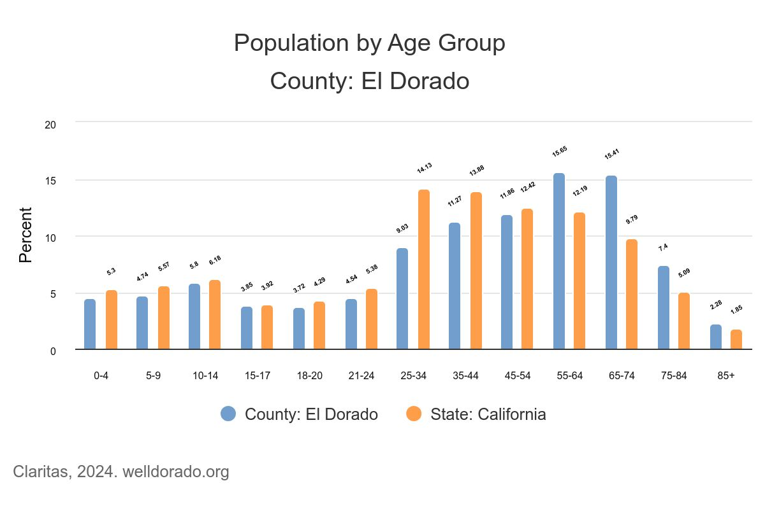
Nearly 35% of El Dorado County is considered rural, with approximately 33% of the county’s population residing toward the western border of the county in the El Dorado Hills and Cameron Park communities. The Tahoe Basin, on the eastern border of the county, is the second most populated center in the county. Vast areas of rural land and National Forest are found between these two major population centers in the east and the west. The rural nature of many unincorporated areas of the county can often times result in challenges to obtaining health services (e.g. transportation services, outreach to residents and public awareness relative to available services).
Figure #: cite welldorado
The population of El Dorado County is aging faster, on average, than many counties in the State of California. Just over 50% of residents in El Dorado County are over the age of 45 (Figure#). The largest age range in El Dorado County is 55-64 range with a median age of 47.1 years, approximately ten years older than the median age of residents in California. Although its overall population growth has been relatively modest, El Dorado County’s senior population has risen at a faster rate than the state’s. The faster growth means there are fewer adults of prime working age.
Household size was also of interest, with one or two person households comprising more than 60% of households in the county. The majority language spoken at home in El Dorado County is English, with an estimated 88.3% of people over the age of 5 speaking only English. Of the 11.7% remining that speak a language other than English at home, 5.9% speak Spanish, 2.8% speak another Indo-European language, 2.8% speak an Asian or Pacific Island language, and 0.3% speak some other language.
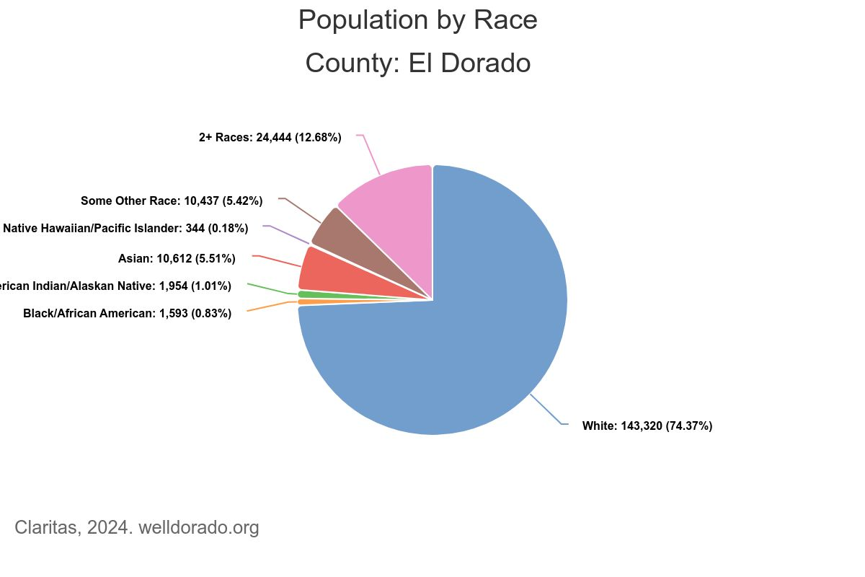
Race and Ethnicity
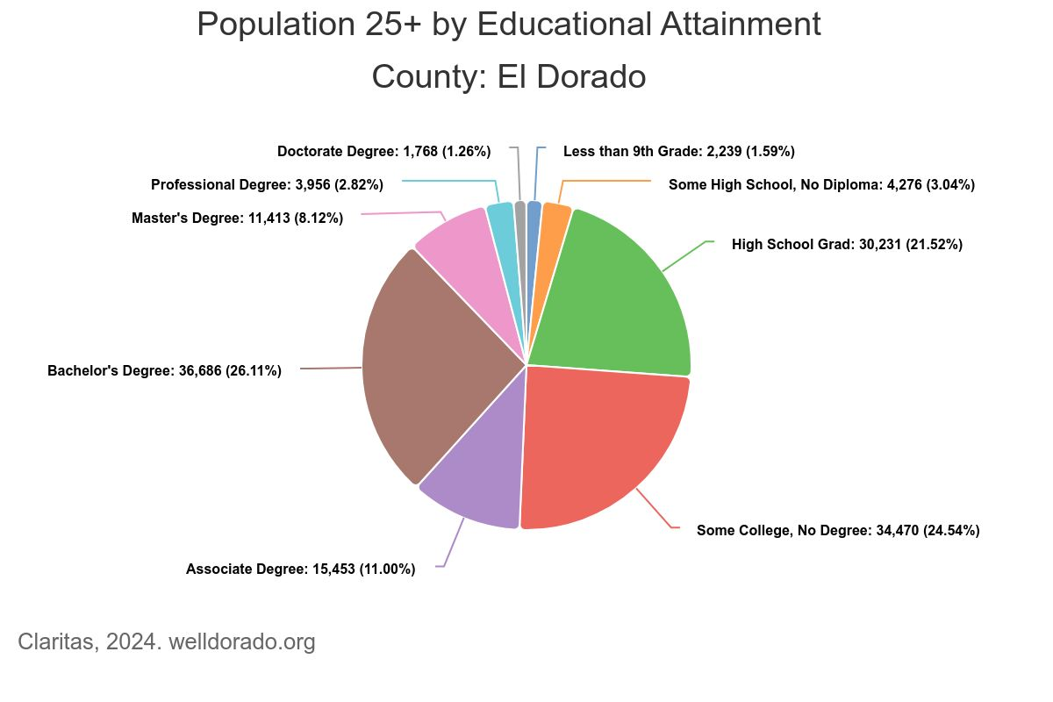
El Dorado County’s racial and ethnic minority populations are proportionately small compared to the rest of California. The terms used to describe racial and ethnic groups in this report are consistent to those used in the 2020 U.S. Census and are self-reports of race or ethnicity. In this format, respondents are first offered two categories for ethnicity (Hispanic/Latino or Not Hispanic/Latino) and then offered seven categories for race identification (White, Black/African American, American Indian/Alaska Native, Asian, Native Hawaiian/Pacific Islander, Some Other Race, 2+ Races. The majority (87%) of residents self-report their ethnicity as Non-Hispanic/Latino while 13% identify as Hispanic or Latino (Figure#). Race demographics also present similar make-ups with predominant number of residents self-reporting as White. El Dorado County experienced a 7.42% growth rate from 2010 to 2024; racial demographics, however, have remained nearly unchanged.
Figure #: cite welldorado
Education, Income and Employment
Residents of El Dorado County tend to have more years of formal education when compared to residents in the rest of California. Approximately 93% of residents have a high school diploma (or equivalent) or higher compared to the California average of 84% (figure#). Education is an important indicator to health because it is closely linked with occupation and income.
Income is the most common measure of socioeconomic status and a strong predictor of the health of a community. The lower an income, the less likely it is a person will follow a health diet or participate in regular physical activity and more likely they will use tobacco products. This leads to a greater likelihood of chronic conditions such as depression, obesity, asthma, diabetes, heart disease, stroke, and premature death.
Figure #: cite welldorado
While approximately 6.18% of families residing in El Dorado County have incomes below the Federal Poverty Level (FPL), several race categories outperform the state when looking at household income (Figure#). As a point of comparison, 8.86% of Californian families live in a household with income below the FPL.
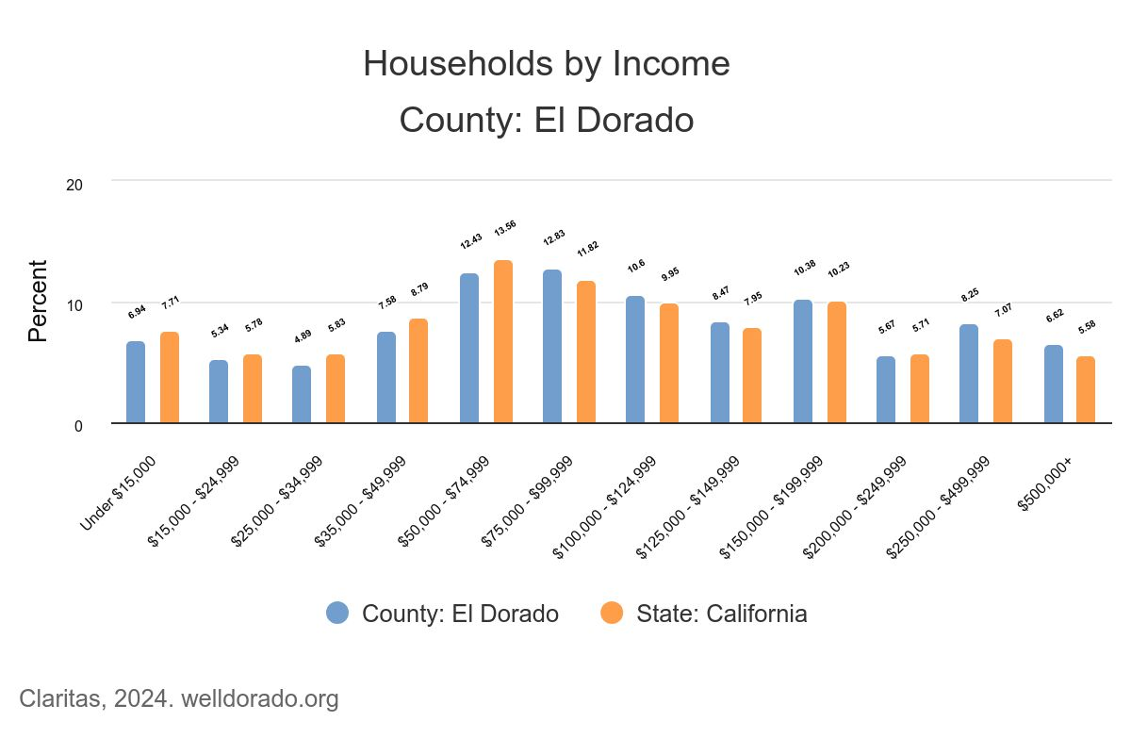
El Dorado County’s 2024 unemployment rate of those 16 years and older was 5.66% compared to 7.31% in California, however there are disparities among communities within the county that range from 4.7% in El Dorado Hills to 9.6% in Georgetown. The unemployment rate is a key indicator of the local economy, as a high rate of unemployment has personal and societal effects. During periods of unemployment, individuals are more likely to feel severe economic strain and mental stress. Unemployment is also related to access to health care, as many individuals receive health insurance benefits through their employer.
Figure #: cite welldorado
School Enrollment Characteristics
There are 15 school districts operating 67 public schools in El Dorado County, serving 31,268 students. The school population has increased 12% since 2018 (N=27,875). Highlighted demographics include (42):
In 2022:
- 30% of students (N=9548) were participating in free and reduced=price meal program
- 6% of students (N=1946) were classified as English Learners, with Spanish as the predominate language at 4.3% (N=1,329)
- 103 students met the definition of foster youth
- The Ethnic Diversity index across all schools in El Dorado County was 36, with Hispanic or Latino designation at 22% of the student population
- 11,274 Children were living socioeconomically disadvantaged
- 855 Children were Homeless
- 92.4% High School Graduation Rate (compared to 84%)

Alpine County Demographics
Population Overview
A total of 1,204 people reside in Alpine County in 738 square miles of land. Alpine county borders California counties Mono County, Calaveras County, Tuolumne County, Amador County and El Dorado County (29). Alpine County is the smallest population of California’s 58 counties. The county is rural with no incorporated cities and few services provided by county departments and agencies (43). Alpine County also has a federally recognized tribe of the Washoe Tribe comprised of 3 bands; Welmelti (northern), Paw La Lu (Carson Valley), and Hung a let ti (southern) (44).
The population of Alpine County is aging fast with the majority of the county being 55 years or older (44%) (figure#). The largest age range in the county is 65- to 74-year-olds. The median age of Alpine County is 41.8 years old; the overall population is mainly comprised of adults who are middle aged and nearing retirement (29).
“Oral health programs such as the mobile van program are vital to the health of residents.” -key informant of Alpine County
Figure#: Alpine County population by age group, 2022

The racial and ethnic minorities in Alpine County are vastly smaller compared to the rest of California. The majority of residents in the county are predominantly White (68%), while Native Americans/Alaskan Natives were the second largest group (20%), as shown in table# below. When examining ethnicity, 87% of residents identified as non-Hispanic or Latino, while 13% did identify either being Hispanic or Latino (table#).
Table#: Alpine County Population by Race, 2022
2022 Population by Race, Alpine County
Race | Population | Percentage
White | 814 | 68%
American Indian or Alaskan Native | 236 | 20%
Asian | 12 | 0.9%
Black or African American | 10 | 0.8%
Native Hawaiian or Other Pacific Islander | 0 | 0%
Some other race | 13 | 0.10%
Two or More Races | 119 | 9%

Table#: Alpine County Population by Ethnicity, 2022
2022 Population by Ethnicity, Alpine County
Ethnicity | Population | Percentage
Hispanic or Latino | 84 | 7%
Non-Hispanic or Latino | 1,120 | 93%

Part 3: Methodology
This report summarizes the most current information available on the oral health of residents in El Dorado County. Where local data was not available, we relied on state data for county and regional data, as well as national data for comparison. Together, these data sources served as our starting point for describing the burden of oral disease in El Dorado County, the accessibility of dental services and the oral health surveillance capacity. Key indicators will be selected to establish baseline data and future targets to meet local objectives.
The oral health program used the Association of State and Territorial Dental Directors (ASTDD) Seven-Step Model as a guide for the project (See figurenum below).
Figure #: Association of State and Territorial Dental Directors (ASTDD) Seven-Step Model
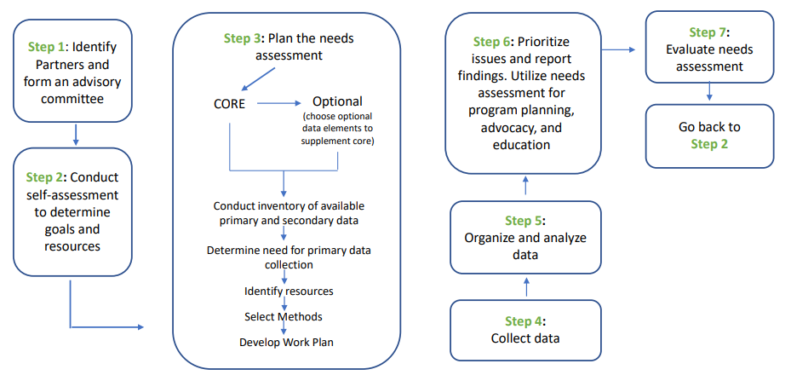
Several strategies were used to gather qualitative and quantitative for this needs assessment, including:
Quantitative Data Analysis
Quantitative data analysis focused on analyzing data through numerical or statistical means, including:
- Primary Data: Interviews, surveys, and health assessments.
- Secondary Data: Publicly available and specific to the United Sates, California, El Dorado County, Alpine County, and from state and county websites.
- Programmatic Data: Oral Health Program website, Kindergarten Oral Health Assessment (KOHA), evaluation plans, and screening. For example, El Dorado County Oral Health Plan 2018-2022, El Dorado Community Oral Health Needs Assessment 2018-2022, El Dorado County Oral Health Program Evaluation Plan 2018-2022, and the Oral Health Plan 2018-2022.
Qualitative Data Analysis
Qualitative data analysis focused on the analysis of subjective and non-numerical data including,
- Key Informant Interviews
  - Conducted with 13 community stakeholders with specialized knowledge or insights regarding oral health needs
  - To inform the needs assessment on systems issues
- Surveys
  - Distributed through OHAC member agencies, partnerships and coalitions to stakeholders and community members
  - To assess the types and magnitude of need for oral health services
- Kindergarten Oral Health Assessments
  - Completed 12 Kindergarten Oral Health Assessments (KOHA) with a registered dental hygienist and health program specialist to identify evidence of cavities, tooth decay, or gum disease and provide education and referrals for dental services. (appendix #)
Limitations

Part 4: Community Input
Primary Data
Qualitative data
Key Informant Interviews
Key informant interviews were conducted as a mechanism to gather insight on the strengths and challenges related to the existing dental service system in El Dorado County. Key informants’ impressions, experiences, and opinions were collected. Results were used to inform this document and the Community Oral Health Improvement Plan.
Key informant interviews were conducted between February and May 2024, where external interviews were conducted with individuals identified by the oral health advisory committee. A total of 15 interviews were completed, where 3 of those interviews come from Alpine County. Each interview was selected for specialized knowledge of the systems that provide oral health services or work closely with El Dorado County and Alpine County residents.
Findings
Results of the key informant interviews indicate that there are 4 areas of opportunity that if addressed, could improve oral health outcomes for people in El Dorado County. These opportunities are presented in the graphic below and are listed by the direst needs at the top (Figure #).
Awareness of Resources
Key informants were asked to provide the organization or agency they worked for and a total of nine different affiliations within the county were identified:
- Community Health Centers
- Office of Education
- Oral Health providers
- Public Health Nurses
- Marshall Medical Center
- New Morning Youth and Family Services
- Shingle Springs Health and Wellness Center
- El Dorado County Health and Human Services
- Alpine County representatives

“During COVID, patients weren’t being seen for 2-3 years and they are just now barely coming back. WE are seeing way more patients now. Appointments are hard to get.”
-key informant (dental professional)

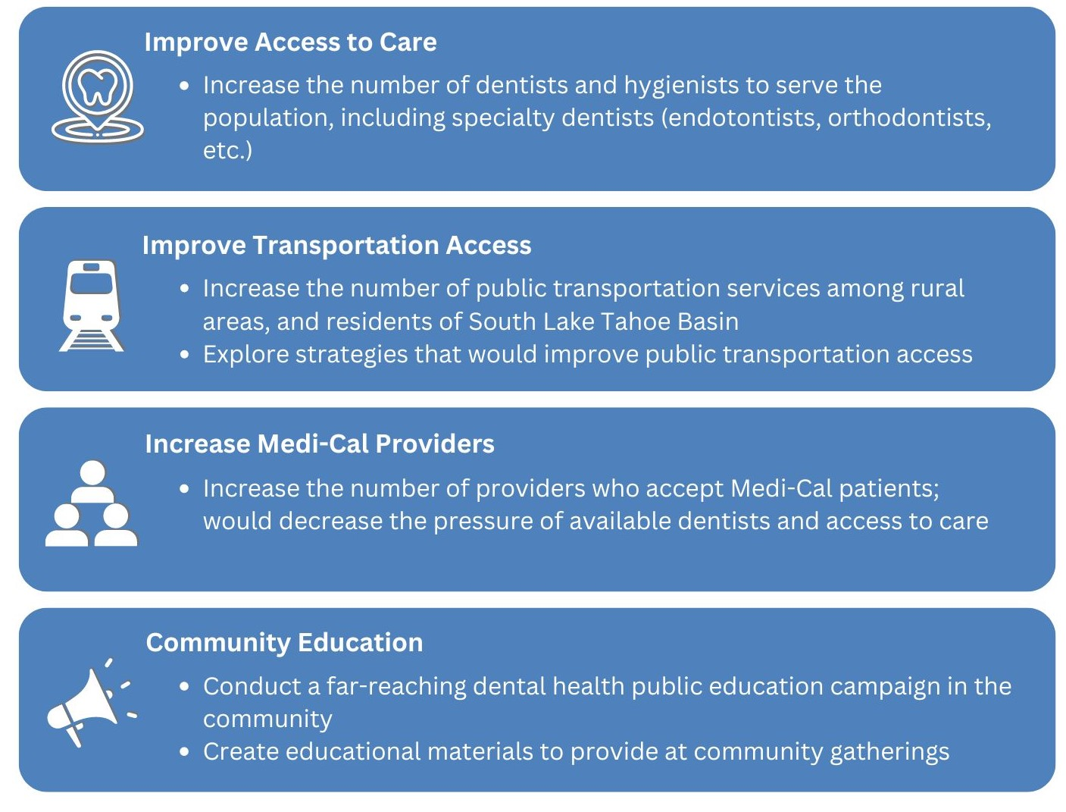

El Dorado Community
Key informant interview participants were also asked about community issues in relation to the organization they were affiliated with. These questions garnered a lot of information on the most common oral health issues and some ideas to address the barriers faced among community members. The oral health issues identified and ideas are listed below in no particular order.
The biggest oral health issues challenging the community:
- Not enough dentists accept medi-cal dental coverage
- Few or no specialty dentists in the county and many residents have to travel to bordering counties
- Poor transportation to get to health care services, especially for residents in the Tahoe Basin
- Financial barriers to cover medical and dental expenses
- Some dentisits will pull adult teeth instead of saving teeth
- Education and oral health literacy: oral health hygiene, prevention, when to go to the dentist, and child oral health care
- Appointment times often take more than a month to get an individual scheduled
- Low income populations don’t have equitable access to medical or dental services
- Oral health issues like caries, untreated decay, periodontal disease, tooth loss, and broken/fractured teeth
Overall there were various different responses to the “main” needs of the community, whether that was strickly about oral health or about general health care. There were other external issues that seemed to influence the health of residents such as homelessness, addicition, county rurality, and lack of medical care. Some of the most common themes from key informants were the importance of avaialable community resources, and the trust that county organizations have with each other. The relationships between residents and the community organizations are also immensely important and determine how accessible resources can support the community and create lasting impacts. There was also a lot of doubts that were expressed toward government involvement amongst community members. Additionally, the rurality of the county also offers up unique challenges to residents across various external and internal factors. Building up the trust with community members and health care organizations has proven to be immensely important, especially when these communications are done face to face.
These interviews were highly informational and also provided insights into what each person observes within their prespective roles and the different cultures of each organization. Additionally, the wide range of survey answers will assist us in acknowledging the various types of gaps and barriers community members face in regard to oral health, as reported by interviewees.
Quantitative Data
The lack of oral health data in El Dorado County inspired the community surveys needed to fill in the primary data that the oral health program is looking to, to focus on priority issues.

Appendix
Kindergarten Oral Health Requirement
Lack of access to dental care is a problem for many El Dorado County Children. Dental disease, one of the most common chronic childhood diseases, effects a child’s quality of life, diminished nutritional status, and school absenteeism (5). California’s Kindergarten Dental Check-up law (AB 1433) requires that children have a dental checkup by May 31 of their first year in public school, at kindergarten or first grade (39). Enacted in 2006, (Emmerson/Laird) helps identify children with unmet oral health needs and provides schools with essential information to ensure their students are healthy and ready to learn. The goal of this program is to establish regular sources of dental care for every child. The program also identifies children who need further examination and dental treatment and identifies barriers to receiving care. The assessment, or evaluation, can be met in many ways. It can be a complete examination and treatment plan performed by a dentist, or it can be a more basic oral health evaluation, such as a screening, which can be performed by a dentist, hygienist, or a registered dental assistant with supervision.
The law directs schools to distribute oral health education materials and the assessment-waiver forms to parents who are registering their children in public school for the first time (39). Schools collect the assessment-waiver document by May 31 of the school year and are responsible to aggregate the data contained on the form and report it, by district, to the County Office of Education by December 31 of each year. In 2018, the law was updated to provide the state dental director with more oversight for the program, including data collection. The oral health grant awarded to local health jurisdictions, including El Dorado County, encourages coordination and reporting on the kindergarten oral health assessment. El Dorado County experienced mid-level compliance with AB 1433, with approximately 67.9% of El Dorado County Kindergarteners received the required oral health assessment in 2024 (Table #).

Table#: El Dorado County Kindergarten Oral Health Assessments, 2024
Schools Assessed | Total Eligible | Total Assessed | % Assessed
Pioneer Elementary | 51 | 38 | 76%
Sutter’s Mill Elementary | 84 | 54 | 65%
Indian Creek Elementary | 109 | 80 | 73%
Camino Elementary | 62 | 40 | 64%
Goal Oak Elementary | 68 | 52 | 76%
Sierra Elementary | 94 | 72 | 76%
Pinewood Elementary | 71 | 61 | 86%
Schnell Elementary | 94 | 80 | 85%
Tahoe Valley Elementary | 114 | 45 | 39%
Bijou Elementary | 67 | 27 | 40%
Sierra House Elementary | 60 | 38 | 63%
Meyers Elementary | 58 | 41 | 72%
El Dorado County Total | 932 | 628 | 67.9%

Bibliography

1
CDC. (2019, February 19). Pregnancy and oral health feature | CDC. Www.cdc.gov.
2
National Center for Health Statistics. Percentage of ever having asthma for children under age 18 years, United States, 2019—2022. National Health Interview Survey.
3
Heaton, L., & Sonnek, A. (2022). Americans Are Still Not Getting the Dental Care They Need. CareQuest Institute for Oral Health.
4
Oral Systemic Health. (n.d.). Www.ada.org. https://www.ada.org/resources/research/science-and-research-institute/oral-health-topics/oral-systemic-health
5
CDC. (2019). Oral Health. Oral Health. https://www.cdc.gov/oral-health/about/index.html
6
CDPH. (2019, September). California Oral Health Plan 2019-2023. Www.cdph.ca.gov.
7.
California Department of Public Health. (2019). Oral Health Program. Ca.gov.

8.
CDC. (2024b, May 23). Preventing Oral Diseases and Conditions in Communities. Oral Health.

9.
ADA. (2022, July 9). periodontitis. Www.ada.org. https://www.ada.org/resources/ada-library/oral-health-topics/periodontitis
10
Cleveland clinic . (2023, October 4). Gum (Periodontal) Disease: Causes, Symptoms, Treatment & Prevention. Cleveland Clinic. https://my.clevelandclinic.org/health/diseases/21482-gum-periodontal-disease
11
Centers for Disease Control and Prevention. (2019). CDC - BRFSS. CDC. https://www.cdc.gov/brfss/index.html.
12
CDC. (2024c, June 6). Tooth Loss. Oral Health. https://www.cdc.gov/oral-health/about/about-tooth-loss.html#:~:text=Overview&text=About%201%20in%208%20(13
13
CDC. (2024c, June 6). Oral Cancer. Oral Health. https://www.cdc.gov/oral-health/about/about-oral-cancer.html
14
ADA. (n.d.). Oral Cancer | MouthHealthy - Oral Health Information from the ADA.
15
American Cancer Society. (2024, January 19). Oral Cavity & Oropharyngeal Cancer Key Statistics 2021.
16
Well Dorado. (n.d.). Well Dorado :: Indicators :: Oral Cavity and Pharynx Cancer Incidence Rate :: County : El Dorado. Www.welldorado.org. Retrieved July 25, 2024.
17
U.S. Department of Health and Human Services. (2020). Healthy people 2030. Healthy People 2030; Office of Disease Prevention and Health Promotion.
18
Centers for Disease Control and Prevention. (2021, February 5). Disparities in Oral Health. Centers for Disease Control and Prevention.
19
California Department of Public Health. (2017, April). Error. Www.cdph.ca.gov.
20
World Health Organization. (n.d.). Ending childhood dental caries: WHO implementation manual. Www.who.int.
21
CDC. (2022, April 6). Oral Health Conditions. Centers for Disease Control and Prevention.
22
CDC. (2020, November 19). Tobacco Use. Www.cdc.gov. https://www.cdc.gov/oralhealth/fast-facts/tobacco-use/index.html
23
Versaci, M. B. (2022, April 6). E-cigarette temperature may affect oral health by changing properties of inhaled aerosols. Adanews.ada.org.
24
CDC. (2022b, November 10). About Electronic Cigarettes (E-Cigarettes) . Centers for Disease Control and Prevention.
25
Gorshteyn, I. (2022). Sugar, Drinks and Dental Health. Mouthhealthy.org.
26
CDC. (2023, January 13). Addressing Excessive Alcohol Use: State Fact Sheets.
27
University of Pennsylvania. (2023, June 25). Alcohol And Oral Health. Penn Dental Medicine.
28
Oral Health Foundation. (2023, December 18). Cheers to oral health: The positive impact of giving up alcohol. Oral Health Foundation.
29
United States Census Bureau. (n.d.). Explore Census Data. Data.census.gov
30
CDC. (2020a, February 19). About Fluoride | FAQs | Community Water Fluoridation | Division of Oral Health |
31
American Dental Association. (n.d.). Fluoride: Topical and Systemic Supplements.
32
University of California San Francisco. (n.d.). School Sealant Program. California Oral Health Technical Assistance Center.
33
CDC. (2019c, October 15). School Sealant Programs. Www.cdc.gov.
34
DHCS. (2019). DHCS Homepage. Ca.gov. https://www.dhcs.ca.gov/
35
America's Pediatric Dentists. (n.d.). BEST PRACTICES: EXAMINATION, PREVENTION, GUIDANCE/COUNSELING AND TREATMENT.
36
Healthcare.gov. (2018). Children’s Health Insurance Program (CHIP) Eligibility Requirements. HealthCare.gov.
37
Medicaid.gov. (2013). Benefits | Medicaid.gov. Medicaid.gov. https://www.medicaid.gov/chip/benefits/index.html
38
Covered California. (n.d.). California’s Health Benefit Exchange. Hbex.coveredca.com.
39
California Department of Education. (n.d.). Kindergarten Oral Health Assessment Requirement. Www.cde.ca.gov.
40
Kumar, J., & Jackson, R. (n.d.). CALIFORNIA ORAL HEALTH PLAN 2018–2028.
41
Shingle Springs Band of Miwok Indians. (n.d.). Shingle Springs Rancheria. https://www.shinglespringsrancheria.com/
42
Ed Data. (2022). EdData - County Summary - El Dorado. Ed-Data.org.
43
Employment Development Department. (n.d.). Alpine County, California. Labormarketinfo.edd.ca.gov.
44
Alpine County. (n.d.). Native Americans | Alpine County, CA - Official Website. Www.alpinecountyca.gov.
45
El Dorado County. (2024). Human Services. Edcgov.us.

